28-1 ACL Configuration – Lab Exercise

In this lab you will configure standard and extended Access Control Lists.

The routers and PCs have been configured with their network addressing settings, and R2 has a static route for the internal 10.0.1.0/24 and 10.0.2.0/24 networks.

Lab Topology

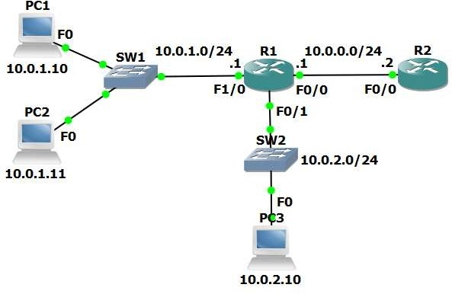

Load the Startup Configurations

Open the ’28-1 ACL Configuration.pkt’ file in Packet Tracer to load the lab.

Numbered Standard ACL

- Verify that all PCs have connectivity to each other, to R1 and to R2.

- Configure and apply a numbered standard ACL on R1 which denies traffic from all hosts in the 10.0.2.0/24 subnet to R2.

The PCs in the 10.0.1.0/24 and 10.0.2.0/24 subnets must maintain connectivity to each other.

The PCs in the 10.0.1.0/24 subnet must maintain connectivity to R2.

- Test that traffic is secured exactly as required.

Verify PC1 and PC2 can ping R2. PC3 cannot ping R2.
PC3 can ping PC1 and PC2.

Numbered Extended ACL

- Configure and apply a numbered extended ACL on R1 which permits Telnet access from PC1 to R2. Telnet to R2 must be denied for all other PCs in the network.

All other connectivity must be maintained. Do not change the existing ACL.
Telnet access has already been enabled on R2. The password is ‘Flackbox’

- Test that traffic is secured exactly as required. Use the command ‘telnet 10.0.0.2’ from the PCs to test and the password ‘Flackbox’. Type ‘exit’ to leave the Telnet session.

Verify that PC1 can ping and Telnet to R2. PC2 can ping R2 but not Telnet to it.
PC3 cannot ping or Telnet to R2. The PCs can all ping each other.

- How many Telnet packets were permitted by the ACL?

Named Extended ACL

- Remove the numbered extended ACL you just configured from the interface. Do not delete the ACL.

- Configure and apply a named extended ACL on R1 as follows:

Permit Telnet from PC1 to R2. Telnet to R2 must be denied for all other PCs in the network.

Permit ping from PC2 to R2. Ping to R2 must be denied for all other PCs in the network.

All other connectivity must be maintained.

- Test that traffic is secured exactly as required.

Verify that PC1 cannot ping R2 but can Telnet to it. PC2 can ping R2 but cannot Telnet to it.
PC3 cannot ping or Telnet to R2. The PCs can all ping each other.

